Polytechnic University of the Philippines

**COLLEGE OF COMPUTER AND INFORMATION SCIENCES**

A. Mabini Campus, Sta. Mesa, Manila

**FPMS: Faculty Performance Monitoring System**

In partial fulfillment of the requirements for the courses:

**COMP 2113 – ADVANCED PROGRAMMING**

**COMP 4023 – DATABASE ADMINISTRATION**

**INTE 3033 – DATABASE MANAGEMENT SYSTEMS 2**

Cadena, John Homer A.

Malto, Emmanuel Reign O.

Mariñas, Levie Anne T.

Pagaduan, John Carlos E.

Tolentino, Ben Hur Adrian Raphael G.

Proponents

October 20, 2017

**Executive Summary**

The Faculty Performance Monitoring System (FPMS) is an information system made by the students of Polytechnic University of the Philippines (PUP). FPMS regulates the records of those professors who submitted reports. The group offers an automated, fast, and web-based system that will ensure that monitoring the reports will be as easy as ever.

The FPMS is exclusive only for the College of Computer and Information Sciences (CCIS) department only, and when given ample time, the system may be distributed to other departments, or even in other schools, by configuring certain parts. The FPMS can be accessed anywhere due to its web-based characteristic, which leads to flexible usage on any browser. Same as the above, given enough time, the flexibility of the system will be applied to mobile phones, and other end devices.

The FPMS has a familiar graphical user-interface, which the users can navigate for themselves even without the help of the developers. The modernization of the design ensures that the transition of the old, lackluster system will give a new outlook while retaining its functionality.

The FPMS offers simple interface, yet easy and functional in the back-end. The group ensures that the system is smoothly running, and has many features to share and present.

**Table of Contents**

**Title Page**

**Executive Summary**

**PART I – PROJECT SPECIFICATIONS REPORT** 4

**1.1.** **INTRODUCTION** 4

**1.2.** **STATEMENT OF THE PROBLEM** 4

**1.3.** **PROJECT OBJECTIVES** 5

**1.3.1.** **General Objectives** 5

**1.3.2.** **Specific Objectives** 5

**1.4.** **SCOPE AND LIMITATION** 5

**1.5.** **PROJECT ASSUMPTIONS** 6

**PART II – DATABASE SPECIFICATIONS REPORT** 6

**2.1.** **BUSINESS RULES** 6

**2.2.** **ENTITY-RELATIONSHIP DIAGRAM** 7

**2.3.** **NORMALIZED RELATIONS** 8

**2.4.** **DATA DICTIONARY** 10

**2.5.** **DATABASE DIAGRAM** 19

**PART III – APPLICATION SPECIFICATIONS REPORT** 21

**3.1.** **APPLICATION DESCRIPTION** 21

**3.2.** **PROSPECT USERS OF THE SYSTEM** 21

**3.3.** **FEATURES SPECIFICATION** 22

**3.4.** **APPLICATION SCREENSHOTS** 23

# **PART I – PROJECT SPECIFICATIONS REPORT**

## **INTRODUCTION**

The project FPMS or Faculty Performance Monitoring System is a web-based information system that monitors the faculty’s submission of requirements catered to the CCIS department. The significance of this system is to accurately monitor which professor submits reports, and those who are not. The late submission of reports can cause the staff, who arranges this matter, to misplace the units of a professor, leading to unattended classes, abandonment issues, and schedule conflicts for some faculty.

The staff/administrator-in-charge that will use this system will be getting privileges to mark their performance, indicate their designated units, and alarm the other professors to submit. The FPMS achieves to lessen the paper usage of the department, lessen the physical work, and automates the entire process of the encoding part.

## **1.2. STATEMENT OF THE PROBLEM**

Professors have the tendency to leave out necessary reports overdue because of their own circumstances. The staff that manages the checking and marking the reports will encounter inconvenience. This hinders the annual reports because of the missing information of a member.

Here are the problems that the system will solve:

* Manual labor, where human error is prone
* Time consumption
* Excess usage of papers and resource
* Information misconception

## **1.3. PROJECT OBJECTIVES**

### **1.3.1. General Objectives**

The main objective of the project was to design and develop a system that would transform and improve the old and manual way of encoding into a computerized process. Since the manual processing is a hectic situation, and commonly attributed to human errors, but is necessary for most of the parts. So, the group decided to make a monitoring system that eases the workflow for the staff-in-charge.

### **1.3.2. Specific Objectives**

Using the Faculty Performance Monitoring System, the group’s specified objectives that they want to achieve is:

* Monitored submission progress in: their functions attended, IPCR, and DTR
* Categorized ranking of a faculty (Instructor, Professor, etc.) and displaying its date of effectivity
* Uploading a soft copy of their file, for submission and back-up purposes
* Deadline-strict system

## **1.4. SCOPE AND LIMITATION**

The system covers the design and the purpose of a monitoring system that will check a faculty’s performance based on their given reports. The system will not cover the schedule assignment.

## **1.5. PROJECT ASSUMPTIONS**

The group assumes that when the system is approved by the higher ups of the department, it will be utilized as a valuable, and indispensable resource. The group also assumed that if they were given enough resources, support, and time, this system will help the entire university campus.

The group also assumed when given enough time, the system can be accessed through several end devices and such, and will become more flexible and sustainable.

# **PART II – DATABASE SPECIFICATIONS REPORT**

## **2.1. BUSINESS RULES**

|  |  |
| --- | --- |
| Rule ID | Business Rule |
| BR_001 | The admin can add a faculty member and another users from the list of faculty members |
| BR_002 | Each faculty members have educational attainment and the admin can update the educational attainment if ever a faculty member is taking up another degree. |
| BR_003 | Every faculty member is entitled to attended functions. |
| BR_004 | A function can be attended by many or all of the faculty members. |
| BR_005 | Each faculty member is assigned reports and has to submit it on time. |
| BR_006 | The reports are submitted periodically. |
| BR_007 | Every report has a deadline. |
| BR_008 | If the faculty fails to submit the deadline on time, then the admin can contact that faculty member to submit the reports that are already 3 days passed the due date. |
| BR_009 | The admin could also attach files for the report. |
| BR_010 | Faculty members also have their own classes assigned to them. |
| BR_011 | Each class schedule has their rooms and subjects determined. |
| BR_012 | The admin can monitor what classes are given to the faculty members. |

Below, are the following business rules that both the group, and the faculty-in-charge approved on:

## **2.2. ENTITY-RELATIONSHIP DIAGRAM**

This is the entity-relationship diagram of the Faculty Performance Monitoring System. This will indicate the ERD of the entire system.

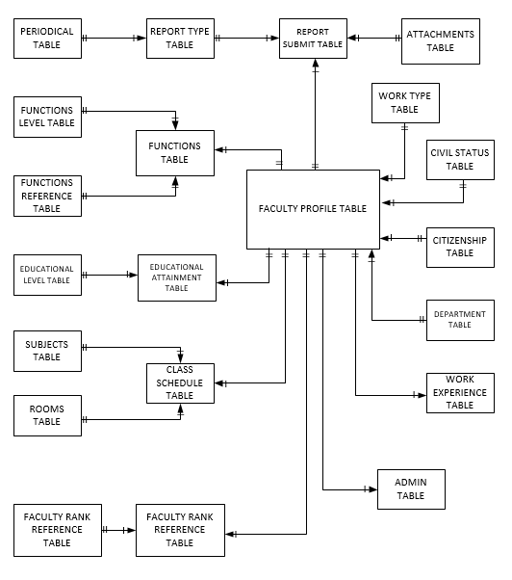

## **2.3. NORMALIZED RELATIONS**

This is the normalized relations of the Faculty Performance Monitoring System. This indicates the normalization of the entire system in 3NF.

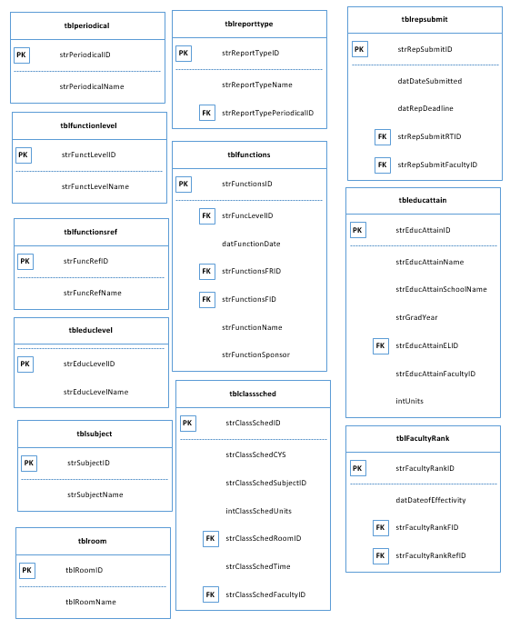

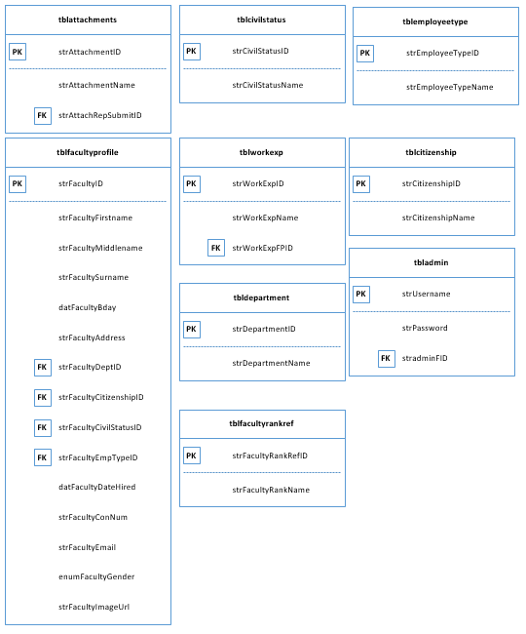

## **2.4. DATA DICTIONARY**

This is the data dictionary of the Faculty Performance Monitoring System. Pages 9-19 will indicate the tables used in the entire system.

|  |  |  |  |  |  |  |  |  |
| --- | --- | --- | --- | --- | --- | --- | --- | --- |
| Table Name: tblAdmin  Table Description: Contains the administrator’s log-in details.  Related Table: tblFacultyProfile | | | | | | | | |
| Key | Field Name | Data Type | Length | Optional | Default Value | Field Validation | Description | Sample Data |
| PK | strUsername | VARCHAR | 45 | N | None | UQ | Username of a staff | Admin |
|  | strPassword | VARCHAR | 45 | N | None | None | Password for the user | 123 |
| FK | strAdminFID | VARCHAR | 15 | N | None | None | Foreign key of strFacultyID from tblFacultyProfile | CCIS-001 |

|  |  |  |  |  |  |  |  |  |
| --- | --- | --- | --- | --- | --- | --- | --- | --- |
| Table Name: tblClassSched  Table Description: Contains the class schedule of the professor.  Related Table: tblEducAttain, tblRoom, tblSubject | | | | | | | | |
| Key | Field Name | Data Type | Length | Optional | Default Value | Field Validation | Description | Sample Data |
| PK | strClassSchedID | VARCHAR | 15 | N | None | None | Identifier of the class schedule. | 001 |
|  | strClassSchedCYS | VARCHAR | 15 | N | None | None | The course, year, and section involved. | BSIT 3-3 |
|  | intClassSchedUnits | INT |  | N | None | None | The number of units a professor have | 3 |
| FK | strClassSchedRoomID | VARCHAR | 15 | N | None | None | Foreign key of strRoomID from tblRoom | R-0001 |
|  | strClassSchedTime | VARCHAR | 20 | N | None | None | Schedule of class time | 1:30-4:30PM |
| FK | strClassSchedFacultyID | VARCHAR | 15 | N | None | UQ | Foreign key of strFacultyID from tblFacultyProfile | CCIS-0002 |
| FK | strClassSchedSubjectID | VARCHAR | 15 | N | None | None | Foreign key of strSubjectID from tblSubject | COMP3013 |

|  |  |  |  |  |  |  |  |  |
| --- | --- | --- | --- | --- | --- | --- | --- | --- |
| Table Name: tblEducAttain  Table Description: Educational attainment of a professor  Related Table: tblEducLevel, tblFacultyProfile, tblClassSched | | | | | | | | |
| Key | Field Name | Data Type | Length | Optional | Default Value | Field Validation | Description | Sample Data |
| PK | strEducAttainID | VARCHAR | 15 | N | None | None | Identifier of the educational attainment | EA-0001 |
|  | strEducAttainName | VARCHAR | 45 | N | None | None | Name of the educational attainment | Bachelor of Science in Computer Science |
|  | strEducAttainSchoolName | VARCHAR | 50 | Y | NULL | None | Name of the school attained | Polytechnic University of the Philippines – Santa Mesa Campus |
|  | strGradYear | VARCHAR | 25 | N | None | None | Year graduated | 1990 |
| FK | strEducAttainELID | VARCHAR | 15 | N | None | None | Foreign key of strEducLevelID from tblEducLevel | EL-0003 |
| FK | strEducAttainFacultyID | VARCHAR | 15 | N | None | None | Foreign key of strFacultyID from tblFacultyProfile | CCIS-0003 |
|  | intUnits | INT |  | Y | None | None | Determines the number of units if a faculty is ongoing | 3 |

|  |  |  |  |  |  |  |  |  |
| --- | --- | --- | --- | --- | --- | --- | --- | --- |
| Table Name: tblEducLevel  Table Description: The level name of the Educational Attainment.  Related Table: tblEducAttain | | | | | | | | |
| Key | Field Name | Data Type | Length | Optional | Default Value | Field Validation | Description | Sample Data |
| PK | strEducLevelID | VARCHAR | 15 | N | None | None | Identifier of education al level | EL-0001 |
|  | strEducLevelName | VARCHAR | 45 | N | None | None | Formal name of the educational attainment name | Elementary |

|  |  |  |  |  |  |  |  |  |
| --- | --- | --- | --- | --- | --- | --- | --- | --- |
| Table Name: tblFacultyProfile  Table Description: Personal profile of each faculty member.  Related Table: tblAdmin, tblEducAttain, tblFunctions, tblRepSubmit, tblDepartment, tblCitizenship,   tblCivilStatus, tblEmployeeType, tblAttachment, tblWorkExp | | | | | | | | |
| Key | Field Name | Data Type | Length | Optional | Default Value | Field Validation | Description | Sample Data |
| PK | strFacultyID | VARCHAR | 15 | N | None | None | Identifier of the faculty | CCIS-0001 |
|  | strFacultyFirstName | VARCHAR | 45 | N | None | None | Professor’s first name | Rachel |
|  | strFacultyMiddleName | VARCHAR | 45 | Y | NULL | None | Professor’s middle name | Atian |
|  | strFacultySurname | VARCHAR | 45 | N | None | None | Professor’s surname | Nayre |
|  | datFacultyBday | DATE |  | N | None | None | Professor’s date of birth | 1975-09-19 |
|  | strFacultyAddress | VARCHAR | 80 | N | None | None | Professor’s address | El Pueblo |
| FK | strFacultyDeptID | VARCHAR | 15 | N | None | None | Foreign key of strDepartmentID department according to tblDepartment | DEPT-0002 |
| FK | strFacultyCitizenshipID | VARCHAR | 15 | N | None | None | Foreign key of strCitizenshipID according to tblCitizenship | CT-0001 |
| FK | strFacultyCivilStatusID | VARCHAR | 15 | N | None | None | Foreign key of strCivilStatusID according to tblCivilStatus | CS-0002 |
|  | datFacultyDateHired | DATE |  | N | None | None | The date when the professor is hired | 1971-03-10 |
|  | strFacultyContNum | VARCHAR | 15 | N | None | UQ | Professor’s functioning contact number | 09123456789 |
|  | strFacultyEmail | VARCHAR | 45 | N | None | UQ | Professor’s provided email address | [reychnayre@gmail.com](mailto:reychnayre@gmail.com) |
|  | strFacultyGender | ENUM |  | N | None | None | Professor’s biological gender | Female |
|  | strFacultyImageUrl | VARCHAR | 80 | N | NULL | None | Professors image in http. | /assets/Faculty/nayre_rachel.jpg |
| FK | strFacultyEmpTypeID | VARCHAR | 15 | N | None | None | Foreign key of strEmployeeTypeID according to tblEmployeeType | ET-0001 |
|  | bitis_Deleted | TINYINT | 4 | N | ‘0’ | None | For Soft Deletion | 0 |

|  |  |  |  |  |  |  |  |  |
| --- | --- | --- | --- | --- | --- | --- | --- | --- |
| Table Name: tblFacultyRank  Table Description: Contains achievement rank of a faculty.  Related Table: tblWorkExp, tblFacultyRankRef | | | | | | | | |
| Key | Field Name | Data Type | Length | Optional | Default Value | Field Validation | Description | Sample Data |
| PK | strFacultyRankID | VARCHAR | 15 | N | None | UQ | Identifier of the faculty rank ID | 01 |
|  | datDateofEffectivity | DATE |  | Y | NULL | None | The date of effectivity | 2011-06-27 |
| FK | strFacultyRankFID | VARCHAR | 15 | N | None | None | Identifier of faculty ID | CCIS-0002 |
| FK | strFacultyRankRefID | VARCHAR | 15 | N | None | None | Foreign key for rank reference IDtable | FR-0001 |

|  |  |  |  |  |  |  |  |  |
| --- | --- | --- | --- | --- | --- | --- | --- | --- |
| Table Name: tblFacultyRankRef  Table Description: Contains the rank name of the Achievement Rank.  Related Table: tblFacultyRank | | | | | | | | |
| Key | Field Name | Data Type | Length | Optional | Default Value | Field Validation | Description | Sample Data |
| PK | strFacultyRankRefID | VARCHAR | 15 | N | None | None | Reference ID of the Faculty Rank | FR-0001 |
|  | strFacultyRankName | VARCHAR | 30 | N | None | UQ | Title given to the professor’s rank | Instructor 1 |

|  |  |  |  |  |  |  |  |  |
| --- | --- | --- | --- | --- | --- | --- | --- | --- |
| Table Name: tblFunctions  Table Description: Contains the functions attended.  Related Table: tblFunctionsRef, tblFunctionsLevel, tblFacultyProfile | | | | | | | | |
| Key | Field Name | Data Type | Length | Optional | Default Value | Field Validation | Description | Sample Data |
| PK | strFunctionsID | VARCHAR | 15 | N | None | None | Unique identifier for the functions attended | 001 |
|  | strFuncLevelID | VARCHAR | 15 | N | None | None | Levels whether: | FL-0004 |
|  | datFunctionDate | DATE |  | N | None | None | Date when the functions attended | 2017-02-35 |
| FK | strFunctionsFRID | VARCHAR | 15 | N | None | None | Foreign key for the functions of a faculty based on surname | FT-0001 |
|  | strFunctionsFID | VARCHAR | 15 | N | None | None | ID for functions at Faculty ID | CCIS-0002 |
|  | bitIsPresent | TINYINT | 4 | N | ‘0’ | None | For soft deletion | 0 |
|  | strFunctionsName | VARCHAR | 80 | N | None | NN | The name of the functions the professors attended | Globe Conference |
|  | strFunctionsSponsor | VARCHAR | 40 | N | None | NN | The sponsor of the functions the professor attended | GLOBE |

|  |  |  |  |  |  |  |  |  |
| --- | --- | --- | --- | --- | --- | --- | --- | --- |
| Table Name: tblFunctionsRef  Table Description: Contains the function references.  Related Table: tblFunctions | | | | | | | | |
| Key | Field Name | Data Type | Length | Optional | Default Value | Field Validation | Description | Sample Data |
| PK | strFuncRefID | VARCHAR | 15 | N | None | None | Identification for the sponsor ID | FT-0001 |
|  | strFuncRefName | VARCHAR | 45 | N | None | None | Name of the sponsor | Conferences |

|  |  |  |  |  |  |  |  |  |
| --- | --- | --- | --- | --- | --- | --- | --- | --- |
| Table Name: tblFunctLevel  Table Description: Contains the function level of the function attended.  Related Table: tblFunctions | | | | | | | | |
| Key | Field Name | Data Type | Length | Optional | Default Value | Field Validation | Description | Sample Data |
| PK | strFuncRefID | VARCHAR | 15 | N | None | None | Identification for the function name | FT-0001 |
|  | strFuncRefName | VARCHAR | 45 | N | None | None | Name of the function level | Intercollege |

|  |  |  |  |  |  |  |  |  |
| --- | --- | --- | --- | --- | --- | --- | --- | --- |
| Table Name: tblPeriodical  Table Description: Contains the periodical reports.  Related Table: tblRepSubmit | | | | | | | | |
| Key | Field Name | Data Type | Length | Optional | Default Value | Field Validation | Description | Sample Data |
| PK | strPeriodicalID | VARCHAR | 15 | N | None | None | ID for the periodical report | P-0001 |
|  | strPerodicalName | VARCHAR | 45 | N | None | None | Name of the period | Bi-Annual |

|  |  |  |  |  |  |  |  |  |
| --- | --- | --- | --- | --- | --- | --- | --- | --- |
| Table Name: tblReportType  Table Description: Contains the report type.  Related Table: tblRepSubmit, tblPeriodical | | | | | | | | |
| Key | Field Name | Data Type | Length | Optional | Default Value | Field Validation | Description | Sample Data |
| PK | strReportTypeID | VARCHAR | 15 | N | None | None | Identifier of the report type | RT-0001 |
| UQ | strReportTypeName | VARCHAR | 45 | N | None | UQ | The name of the report type | Accomplishment Report |
| PK | strReportTypePeriodicalID | VARCHAR | 15 | N | None | None | The identifier of the periodical | P-0003 |

|  |  |  |  |  |  |  |  |  |
| --- | --- | --- | --- | --- | --- | --- | --- | --- |
| Table Name: tblRepSubmit  Table Description: Contains the reports submitted.  Related Table: tblFacultyProfile, tblReportType, tblAttachment | | | | | | | | |
| Key | Field Name | Data Type | Length | Optional | Default Value | Field Validation | Description | Sample Data |
| PK | strRepSubmitID | VARCHAR | 15 | N | None | None | Unique identifier of the report submission | RS-0001 |
|  | datDateSubmitted | DATE |  | Y | NULL | None | Professor’s date of the submitted report | 2017-03-31 |
|  | strRepSubmitRTID | VARCHAR | 15 | N | None | None | ID of Report Type | RT-0001 |
|  | strRepSubmitFacultyID | VARCHAR | 15 | N | None | None | ID of Faculty | CCIS-0001 |
|  | datRepDeadline | VARCHAR | 15 | N | NULL | None | Reports’ date of deadline | 2017-07-15 |

|  |  |  |  |  |  |  |  |  |
| --- | --- | --- | --- | --- | --- | --- | --- | --- |
| Table Name: tblAttachment  Table Description: Handles attachments of the professors.  Related Table: tblRepSubmit | | | | | | | | |
| Key | Field Name | Data Type | Length | Optional | Default Value | Field Validation | Description | Sample Data |
| PK | strAttachmentID | VARCHAR | 15 | N | None | None | Identifier of the attachment | 001 |
|  | strAttachmentName | VARCHAR | 80 | N | None | None | Name of the Attachment | Prof. Nayre 1st Quarter Report |
|  | strAttachmentRepSubmitID | VARCHAR | 15 | N | None | None | Foreign key of strRepSubmitID from tblRepSubmit | RS-0001 |

|  |  |  |  |  |  |  |  |  |
| --- | --- | --- | --- | --- | --- | --- | --- | --- |
| Table Name: tblCitizenship  Table Description: Contains the citizenship info of the professors.  Related Table: tblFacultyProfile | | | | | | | | |
| Key | Field Name | Data Type | Length | Optional | Default Value | Field Validation | Description | Sample Data |
| PK | strCitizenshipID | VARCHAR | 15 | N | None | None | Identifier of the attachment | CT-0001 |
|  | strCitizenshipName | VARCHAR | 45 | N | None | None | Name of the Attachment | Filipino |

|  |  |  |  |  |  |  |  |  |
| --- | --- | --- | --- | --- | --- | --- | --- | --- |
| Table Name: tblCivilStatus  Table Description: Contains the civil status info of the professors.  Related Table: tblFacultyProfile | | | | | | | | |
| Key | Field Name | Data Type | Length | Optional | Default Value | Field Validation | Description | Sample Data |
| PK | strCivilStatusID | VARCHAR | 15 | N | None | None | Identifier of the professor’s civil status | CS-0001 |
|  | strCivilStatusName | VARCHAR | 45 | N | None | None | The current civil status of the professor | Single |

|  |  |  |  |  |  |  |  |  |
| --- | --- | --- | --- | --- | --- | --- | --- | --- |
| Table Name: tblDepartment  Table Description: Contains the department info of the professors.  Related Table: tblFacultyProfile | | | | | | | | |
| Key | Field Name | Data Type | Length | Optional | Default Value | Field Validation | Description | Sample Data |
| PK | strDepartmentID | VARCHAR | 15 | N | None | None | Identifier of the professor’s department | DEPT-0001 |
|  | strDepartmentName | VARCHAR | 45 | N | None | None | The current department of the professor | Computer Science |

|  |  |  |  |  |  |  |  |  |
| --- | --- | --- | --- | --- | --- | --- | --- | --- |
| Table Name: tblEmployeeType  Table Description: Contains the department info of the professors.  Related Table: tblFacultyProfile | | | | | | | | |
| Key | Field Name | Data Type | Length | Optional | Default Value | Field Validation | Description | Sample Data |
| PK | strEmployeeTypeID | VARCHAR | 15 | N | None | None | Identifier of the employee type | ET-0001 |
|  | strEmployeeTypeName | VARCHAR | 45 | N | None | None | The professor status in work | Employee |

|  |  |  |  |  |  |  |  |  |
| --- | --- | --- | --- | --- | --- | --- | --- | --- |
| Table Name: tblRoom  Table Description: Contains the room that a professor stationed with  Related Table: tblClassSched | | | | | | | | |
| Key | Field Name | Data Type | Length | Optional | Default Value | Field Validation | Description | Sample Data |
| PK | strClassRoomID | VARCHAR | 15 | N | None | None | Identification of the class room used | R-0001 |
|  | strClassRoomName | VARCHAR | 45 | N | NULL | None | Room name of the professor’s class | E-412 |

|  |  |  |  |  |  |  |  |  |
| --- | --- | --- | --- | --- | --- | --- | --- | --- |
| Table Name: tblSubject  Table Description: Contains the subjects that the professor handles.  Related Table: tblClassSched | | | | | | | | |
| Key | Field Name | Data Type | Length | Optional | Default Value | Field Validation | Description | Sample Data |
| PK | strSubjectID | VARCHAR | 15 | N | None | None | Identification of the class room used | COMP3013 |
|  | strSubjectName | VARCHAR | 45 | N | None | None | Room name of the professor’s class | Database Management System 2 |

|  |  |  |  |  |  |  |  |  |
| --- | --- | --- | --- | --- | --- | --- | --- | --- |
| Table Name: tblWorkExp  Table Description: Contains the professors work experiences.  Related Table: tblWorkExp | | | | | | | | |
| Key | Field Name | Data Type | Length | Optional | Default Value | Field Validation | Description | Sample Data |
|  | strWorkExpID | VARCHAR | 15 | N | None | None | Identification of the work experience | 0001 |
|  | strWorkExpName | VARCHAR | 100 | N | None | None | Name of the work experience | Junior Programmer |
| PK | strWorkExpFPID | VARCHAR | 15 | N | None | None | Identification of work experience in tblFacultyProfile | CCIS-0002 |

## **2.5. DATABASE DIAGRAM**

This is the generated database diagram of the Faculty Performance Monitoring System and was made using in SQL Workbench. Next page, it displays the database diagram of the entire system.

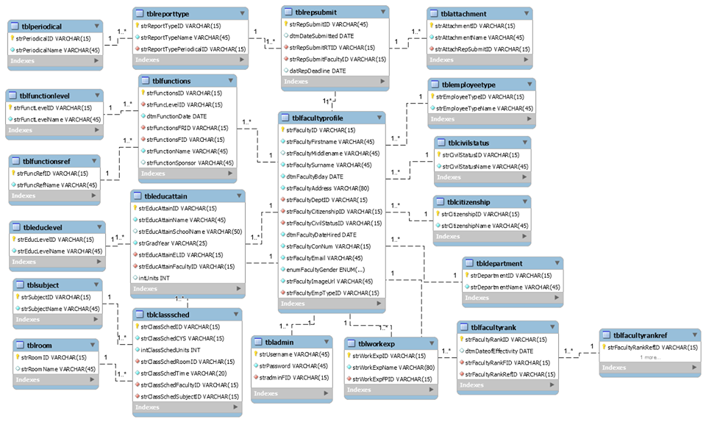

# 

# **PART III – APPLICATION SPECIFICATIONS REPORT**

## **3.1. APPLICATION DESCRIPTION**

In the group’s project, the admin will provide necessary information about his/her information to have an account in the system. The admin then will provide required info for a faculty, using a faculty profile in order to fill all credentials. Since that the profile and their activity is connected, it is easy to determine which report that a staff is not submitting yet.

The admin can also upload attachments, or soft copy files either for submission, or for back-up purposes. The user will encounter a checkbox that marks the submitted report based on the reports a faculty surrendered.

The admin can also adjust the date of the deadline and the date of the faculty’s rank effectivity, and also can contact the faculty that who didn’t submit past the due date.

## **3.2. PROSPECT USERS OF THE SYSTEM**

The system’s prospect user/s might be a staff or a faculty that is entrusted by a higher-up of the department to encode the reports of the other faculties. It is either the Dean, or a faculty that is second-on-command, or an entrusted staff/faculty with regards of the upper position.

## **3.3. FEATURES SPECIFICATION**

|  |  |  |
| --- | --- | --- |
| Feature ID: | | Feat-001 |
| Feature Name: | | Faculty Profile |
| Business Rule ID: | | BR_001, BR_002 |
| User Story: | | |
| 1. | An admin/user is able to add, and update a faculty at will | |
| 2. | An admin/user can add and edit a faculty’s personal information, such as their name, date of birth, their educational attainment (and update the educational attainment when the faculty chooses to pursue his/her degree), etc. | |
| 3. | An admin/user can add, and update work experiences, and the date commence/ended. | |

|  |  |  |
| --- | --- | --- |
| Feature ID: | | Feat-002 |
| Feature Name: | | Functions Attended Tab |
| Business Rule ID: | | BR_003, BR_004 |
| User Story: | | |
| 1. | The admin can indicate what functions a faculty have attended, such as seminars, parties, etc. | |
| 2. | The user/admin can also indicate that the function can be attended by many or every faculty/staff | |

|  |  |  |
| --- | --- | --- |
| Feature ID: | | Feat-003 |
| Feature Name: | | Reports Tab |
| Business Rule ID: | | BR_005, BR_006, BR_007, BR_008, BR_009 |
| User Story: | | |
| 1. | The user/admin must assign the reports needed to a faculty/staff | |
| 2. | The user can adjust the date of deadline | |
| 3. | The admin can contact the faculty who have missing reports | |
| 4. | The admin can also attach a file/soft copy file | |
| 5. | The user can sort out the reports whether it is Bi-Annual, Monthly, Quarterly, or Periodical | |
| 6. | The amount of reports submitted determines the faculty rank | |

|  |  |  |
| --- | --- | --- |
| Feature ID: | | Feat-004 |
| Feature Name: | | Schedule Tab |
| Business Rule ID: | | BR_010, BR_011, BR_0012 |
| User Story: | | |
| 1. | The admin can monitor the classes a professor has | |
| 2. | The admin can also see the schedule of the rooms, and the subject that they currently taking. | |

## **3.4. APPLICATION SCREENSHOTS**

|  |  |
| --- | --- |
| Form Name: | Log-in Page |
| Description: | The first form that the user will see |
| Feature ID: |  |

Figure 1.0. Welcome Page

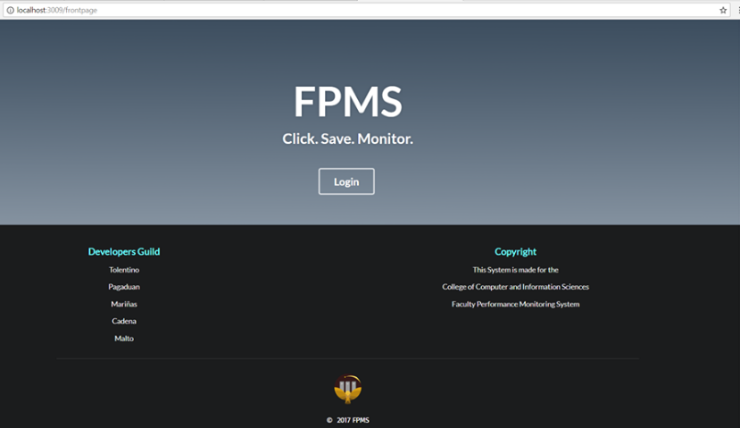

|  |  |
| --- | --- |
| Form Name: | Home Page |
| Description: | The home page of FPMS |
| Feature ID: |  |

Figure 2.0. Home Page

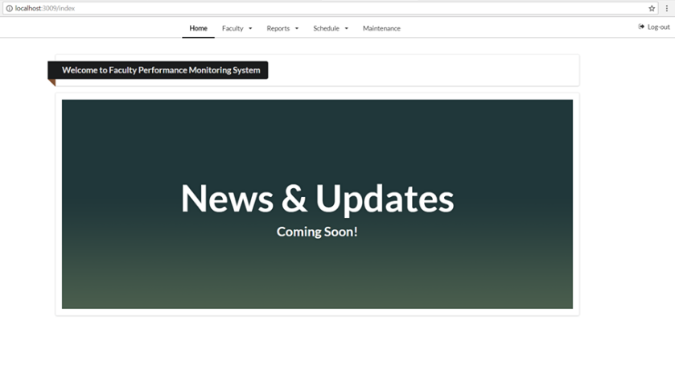

|  |  |
| --- | --- |
| Form Name: | Faculty Page |
| Description: | Reveals all faculties in the CCIS department |
| Feature ID: | **Feat-001** |

Figure 3.0. Faculty Page

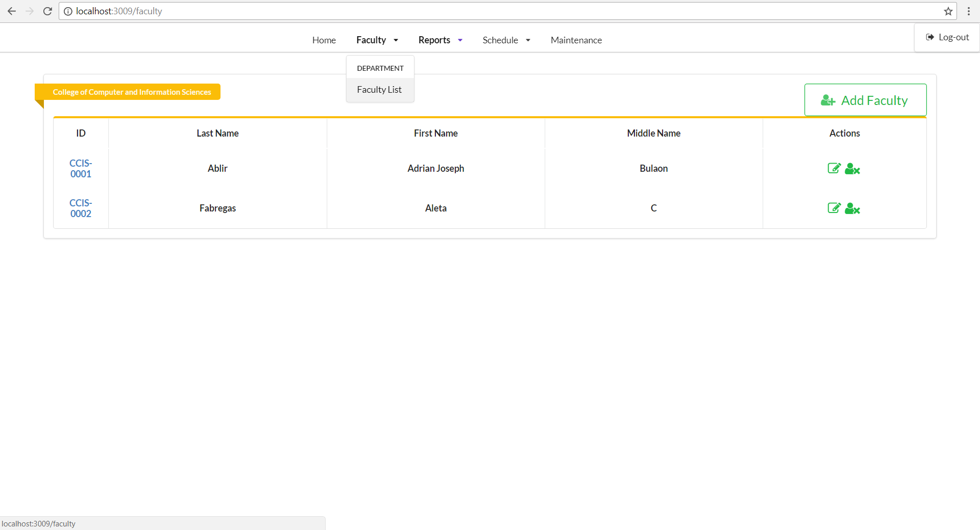

|  |  |
| --- | --- |
| Form Name: | Faculty Profile: Personal Information |
| Description: | When clicked, the faculty’s personal information will be revealed |
| Feature ID: | Feat-001 |

Figure 3.1. Faculty Profile: Personal Information

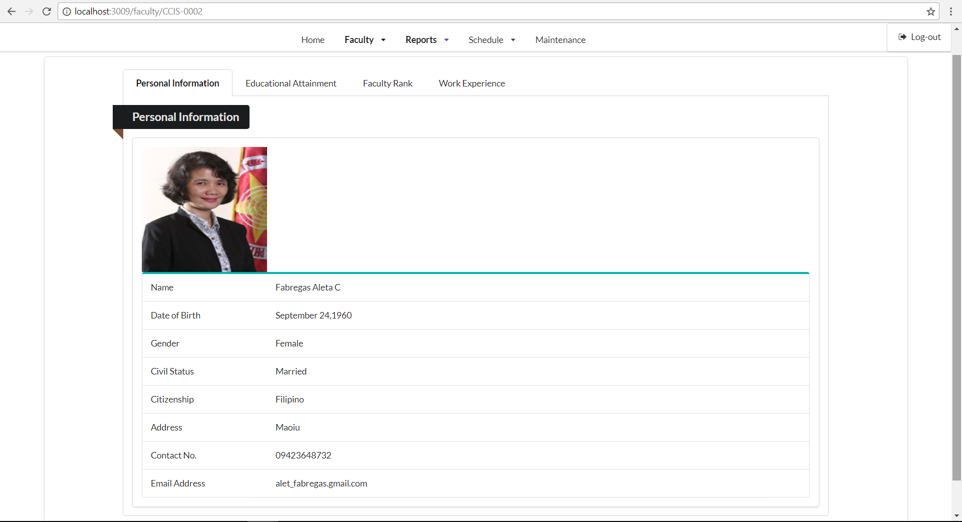

|  |  |
| --- | --- |
| Form Name: | Faculty Information – Add |
| Description: | This form adds CCIS faculties |
| Feature ID: | **Feat-001** |

Figure 3.1.1 Faculty List: Add

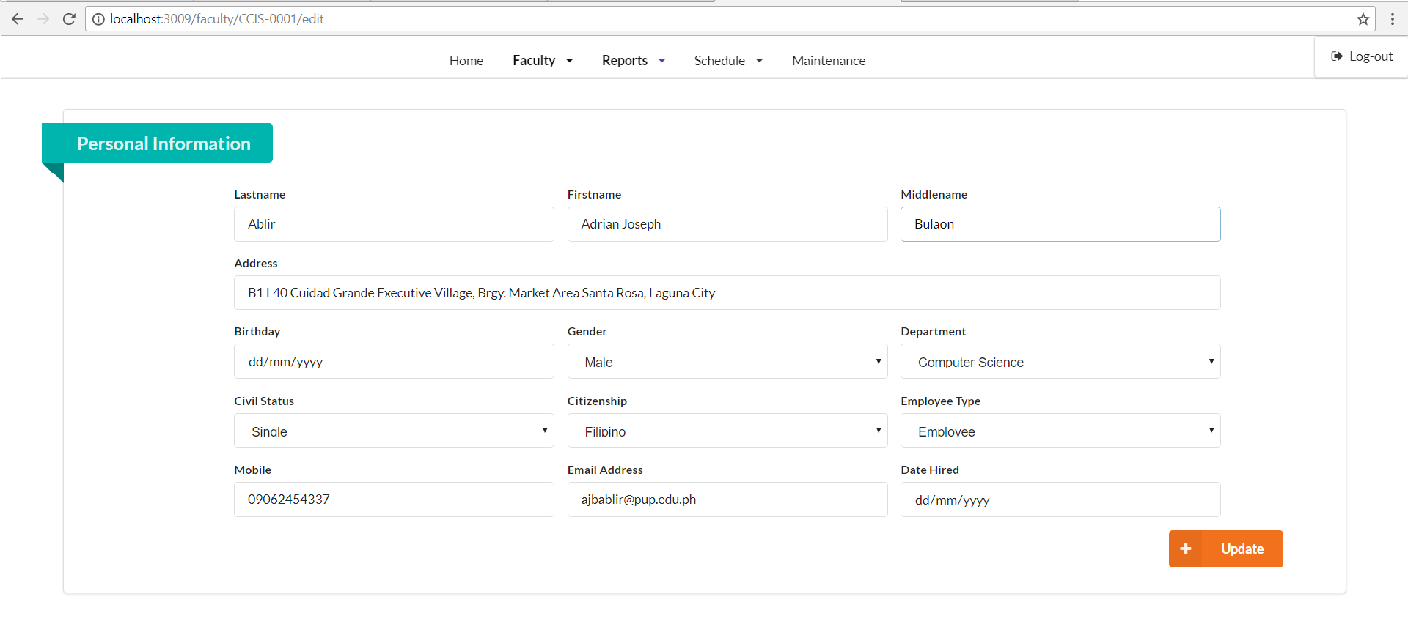

|  |  |
| --- | --- |
| Form Name: | Faculty Profile: Educational Attainment |
| Description: | When the Educational Attainment tab is clicked, the information regarding his/her educational background will reveal |
| Feature ID: | Feat-001 |

Figure 3.2. Faculty Profile: Educational Attainment

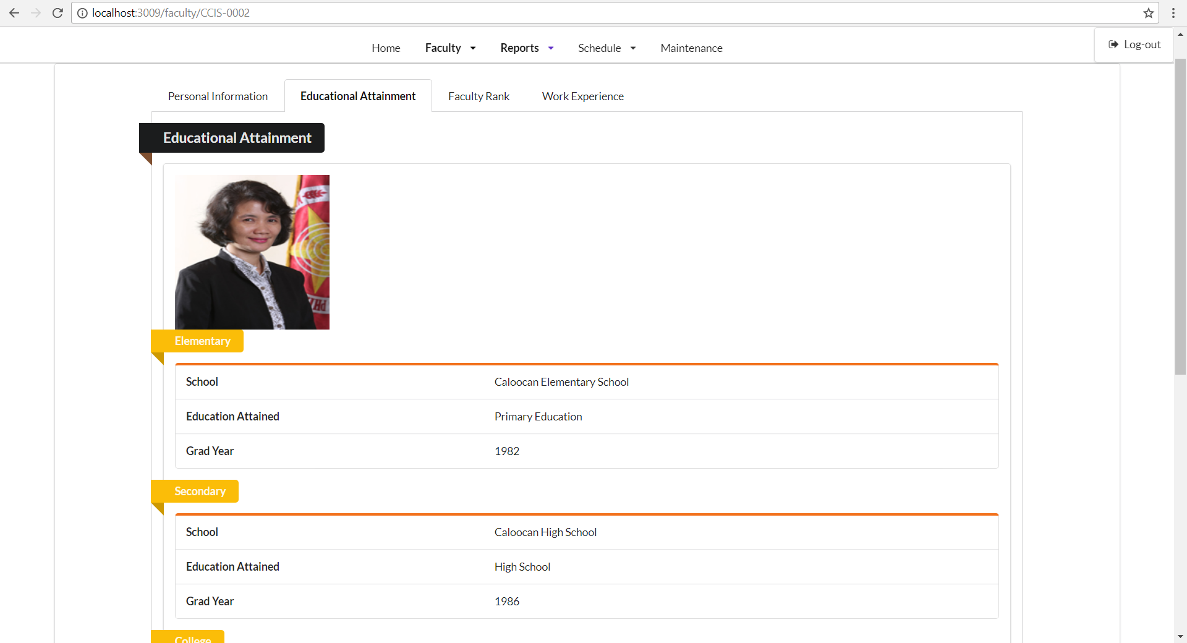

|  |  |
| --- | --- |
| Form Name: | Faculty Profile: Educational Attainment – Add |
| Description: | When the Educational Attainment tab is clicked, the information regarding his/her educational background will reveal |
| Feature ID: | Feat-001 |

Figure 3.2.1 Faculty Profile: Educational Attainment – Add

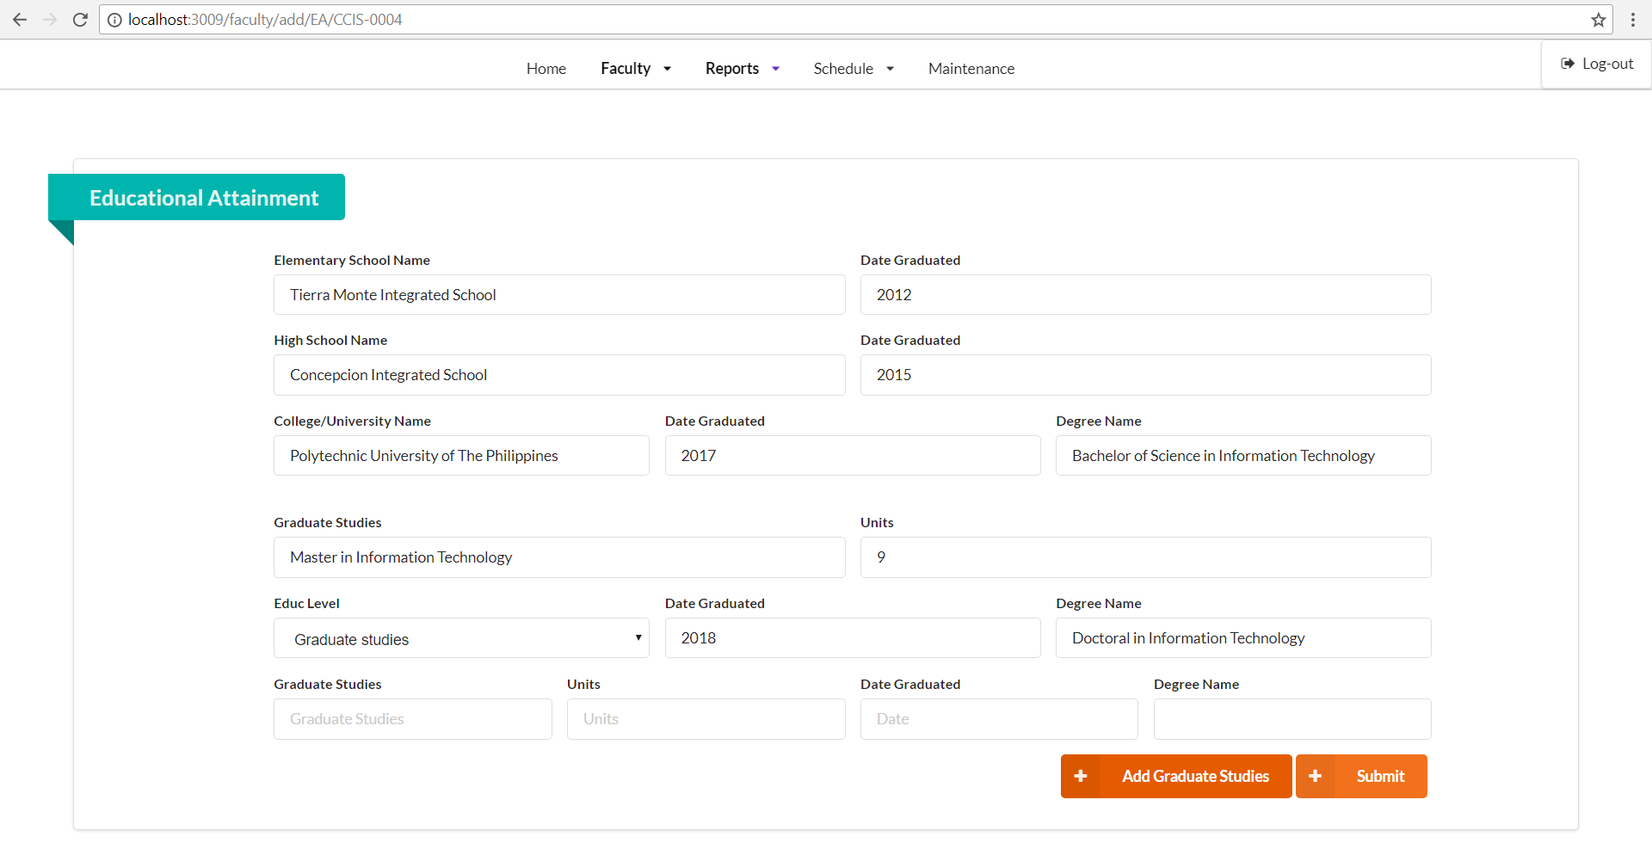

|  |  |
| --- | --- |
| Form Name: | Faculty Profile: Faculty Rank |
| Description: | When clicked, this will display the faculty’s ranks achievement, and its date of effectivity. You can also add ranks at will. |
| Feature ID: | Feat-001 |

Figure 3.3. Faculty Profile: Rank Achievement

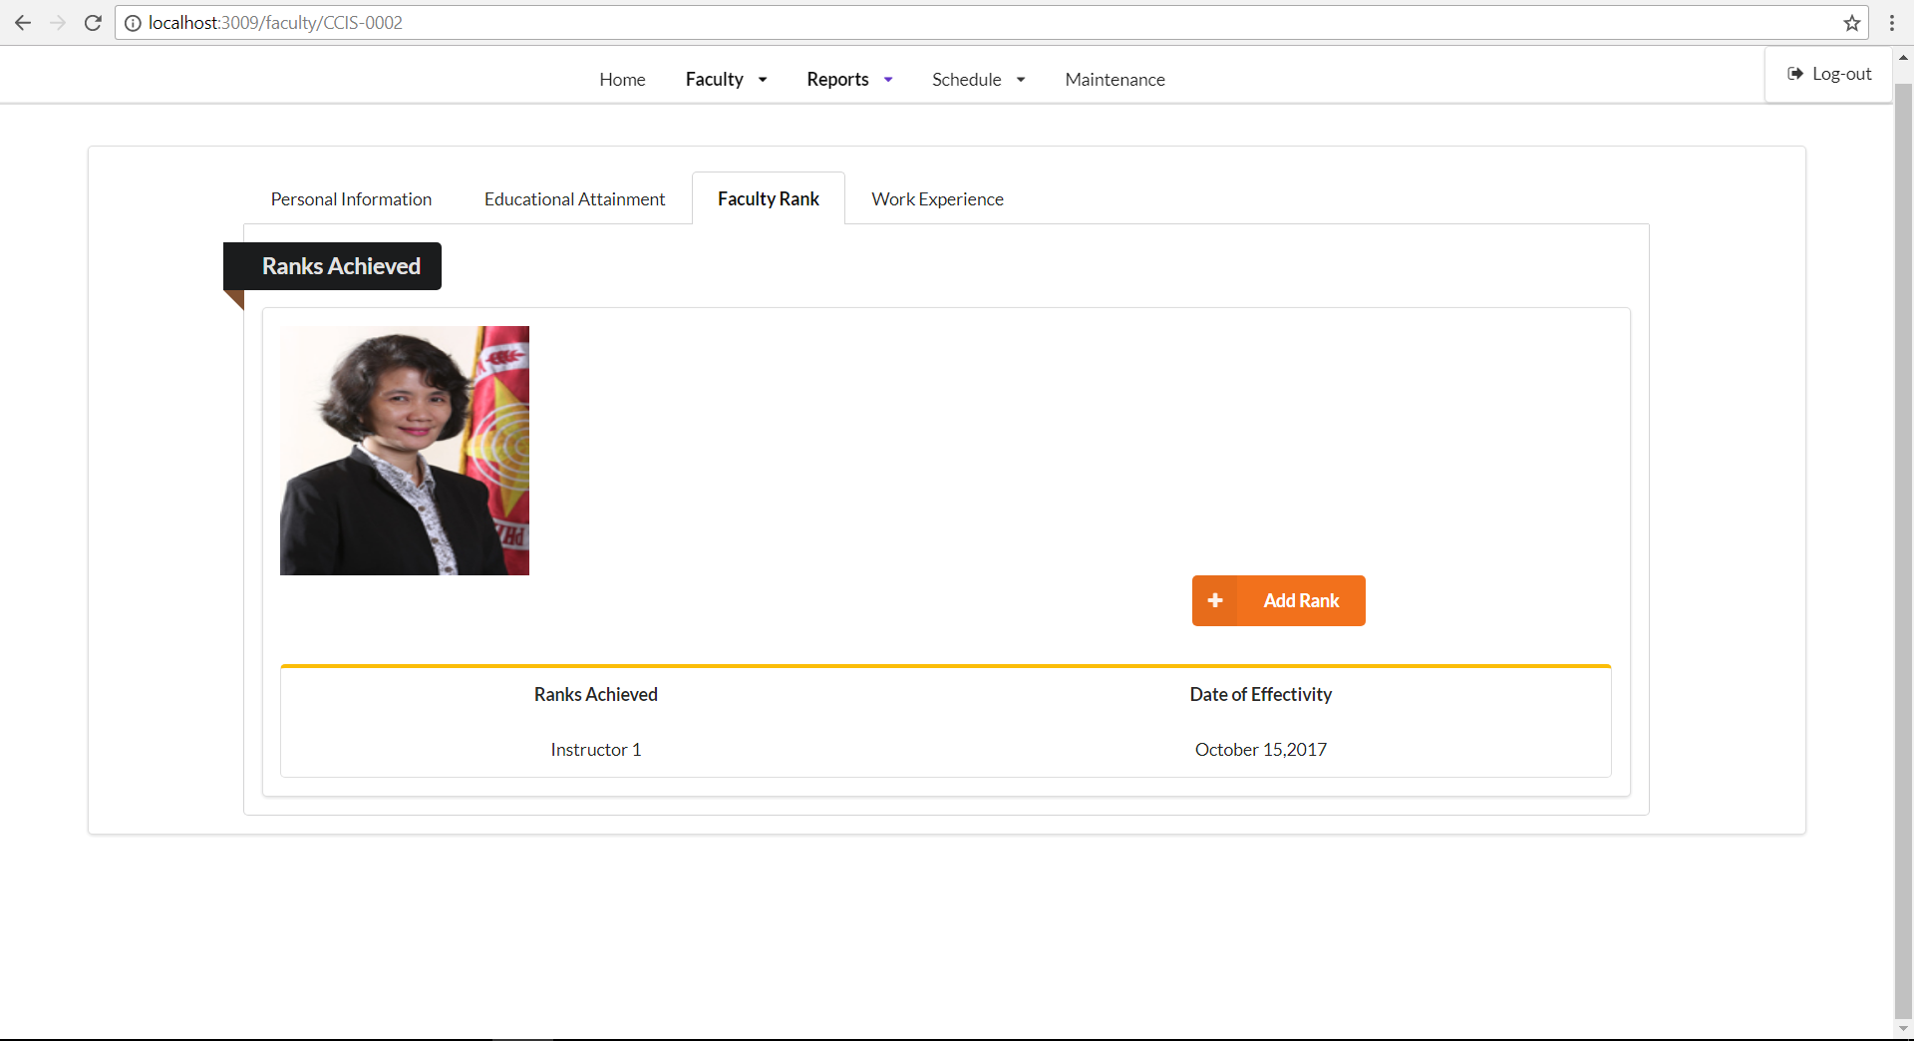

|  |  |
| --- | --- |
| Form Name: | Faculty Ranking – Assign |
| Description: | This form assigns the selected faculty’s rank |
| Feature ID: | Feat-003 |

Figure 3.3.1 Maintenance: Faculty Rank - Add

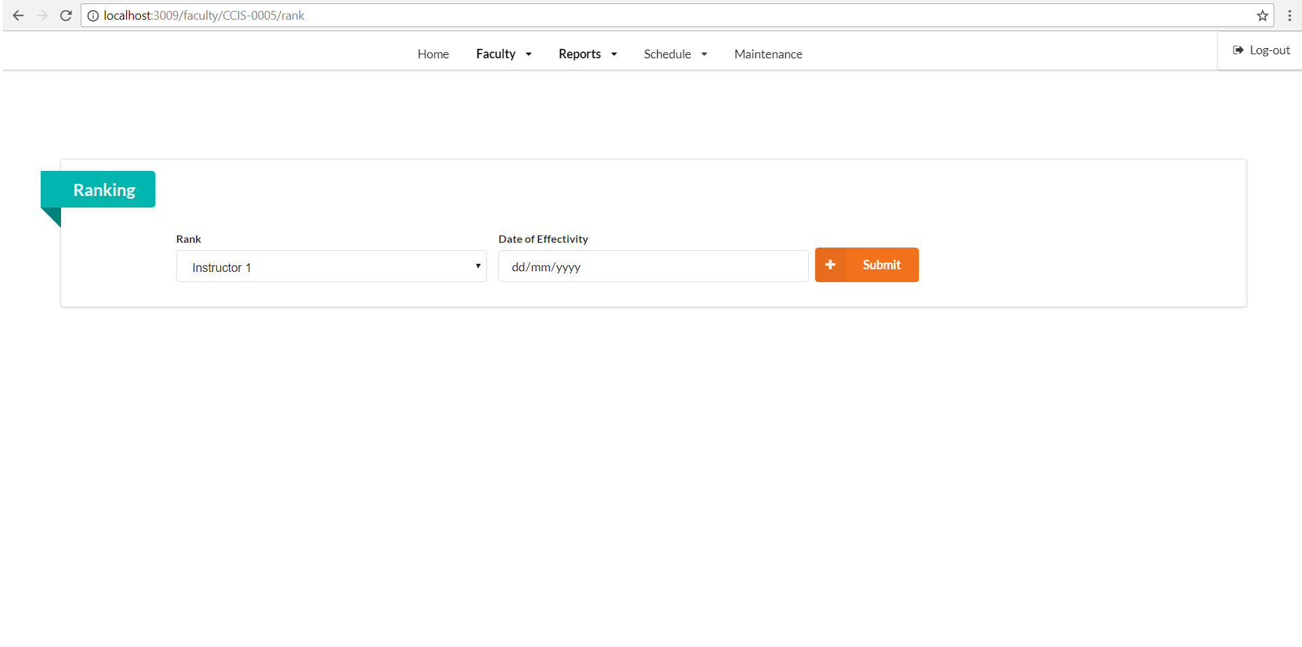

|  |  |
| --- | --- |
| Form Name: | Faculty Profile: Work Experience |
| Description: | When clicked, it will reveal what is the faculty’s work experience, and it also displays how many years he/she used to work. |
| Feature ID: | Feat-001 |

Figure 3.4. Faculty Profile: Work Experience

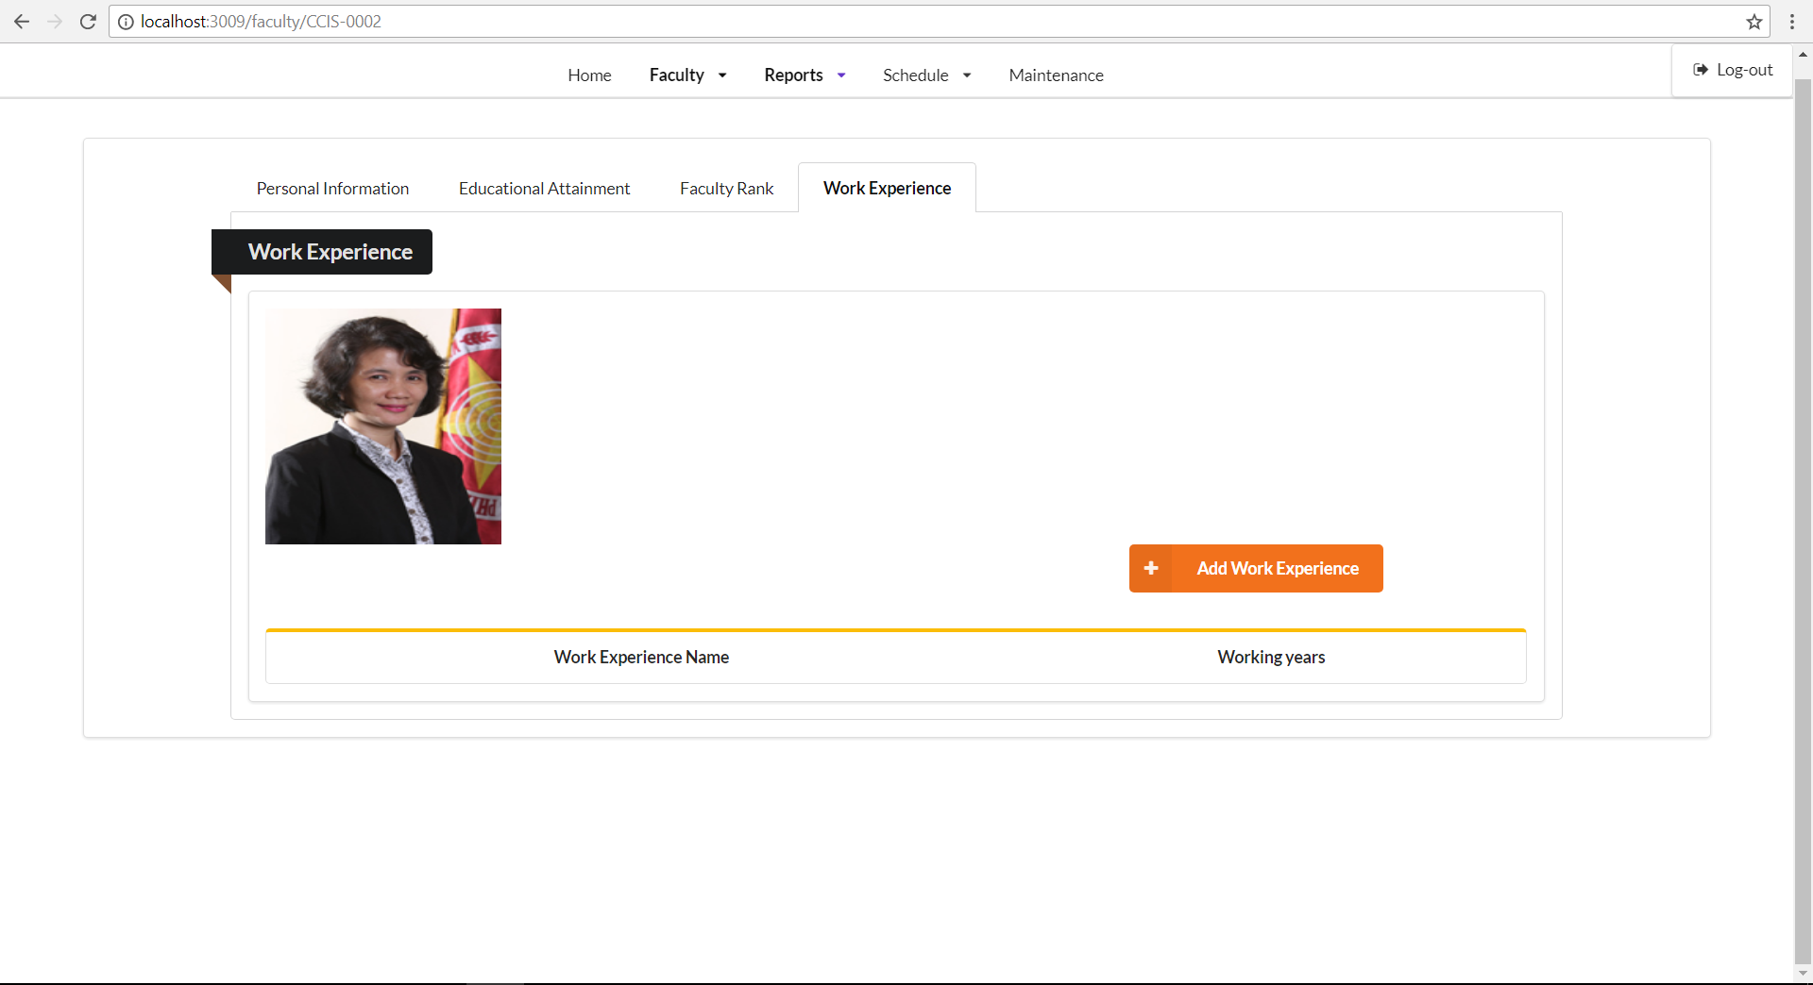

|  |  |
| --- | --- |
| Form Name: | Faculty Profile: Work Experience Input |
| Description: | When the “Add Work Experience” button is clicked, it will take the admin to a form where he/she can fill up the work experience and the working year the faculty had. |
| Feature ID: | Feat-001 |

Figure 3.4.1. Faculty Profile: Work Experience Input

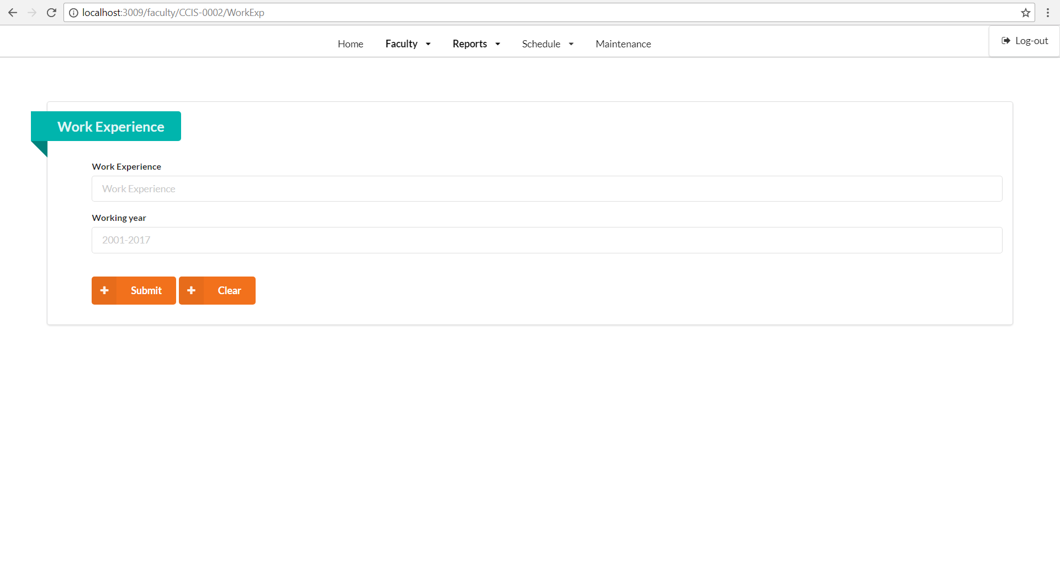

|  |  |
| --- | --- |
| Form Name: | Functions Attended |
| Description: | Reveals the professor’s functions that he/she attended |
| Feature ID: | Feat-002 |

Figure 4.0. Functions: List of Functions attended by the Professor

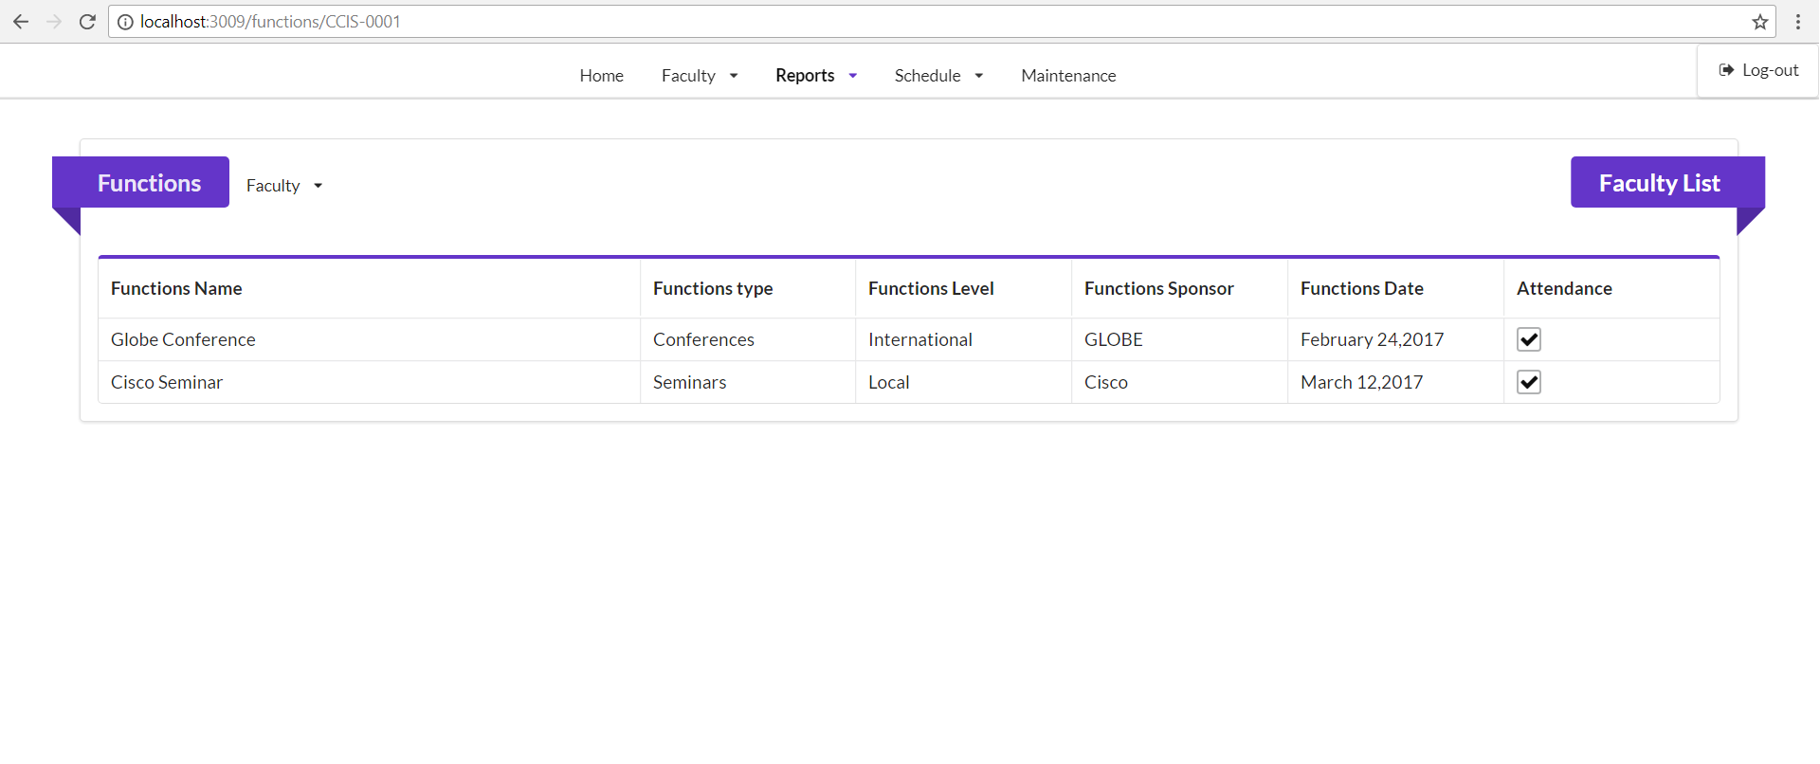

|  |  |
| --- | --- |
| Form Name: | Faculty Profile: Educational Attainment |
| Description: | Assignment for the Educational Attainment of a faculty |
| Feature ID: | Feat-002 |

Figure 4.1. Functions: Input

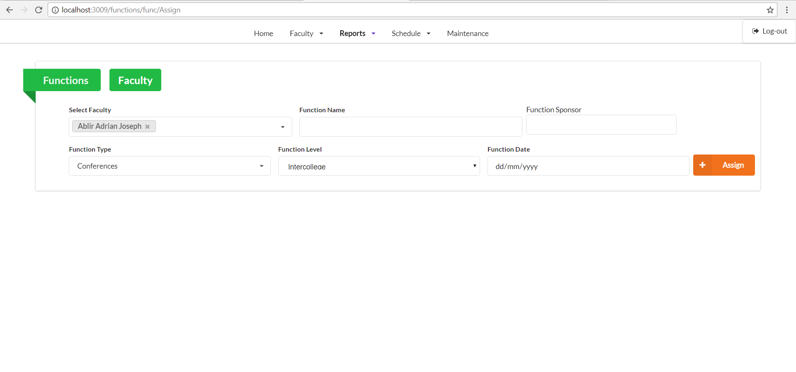

|  |  |
| --- | --- |
| Form Name: | Reports – Individual Performance Commitment and Review |
| Description: | Reveals the submitted report of a professor |
| Feature ID: | Feat-003 |

Figure 5.0. Faculty Reports: Bi-annual Reports List

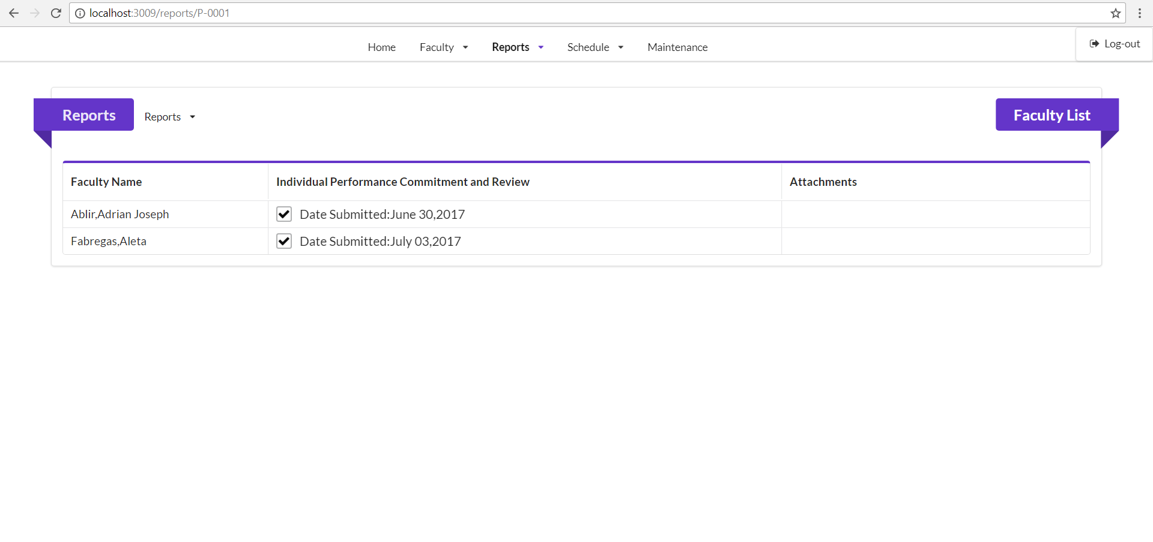

|  |  |
| --- | --- |
| Form Name: | Reports – Accomplishment Report |
| Description: | Reveals the date when did the faculty submitted their report |
| Feature ID: | Feat-003 |

Figure 5.1. Faculty Reports: Quarterly Reports List

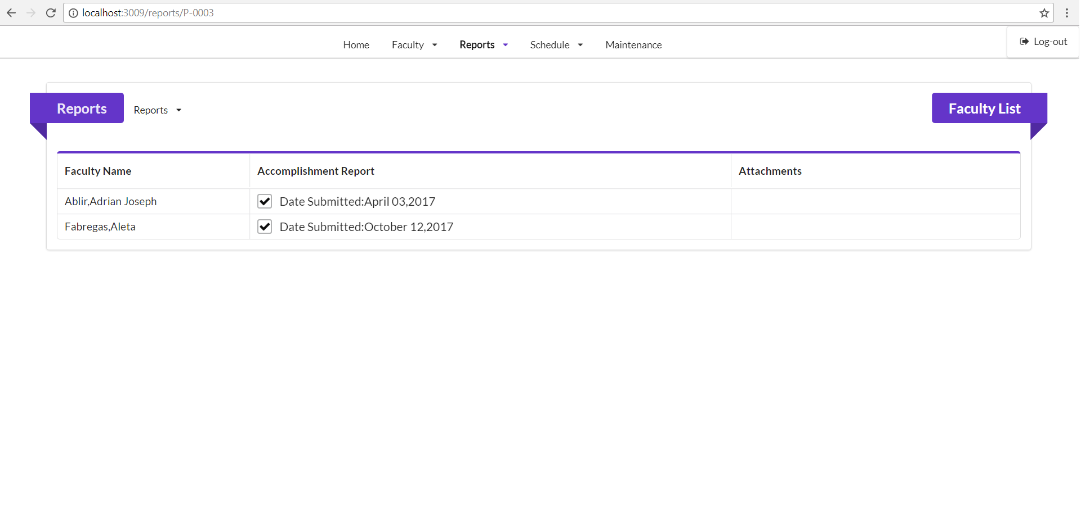

|  |  |
| --- | --- |
| Form Name: | Maintenance Category |
| Description: | This is the maintenance form where if there are any changes to the personal information of a faculty. |
| Feature ID: | Feat-001, Feat-002, Feat-003 |

Figure 6.0 Maintenance

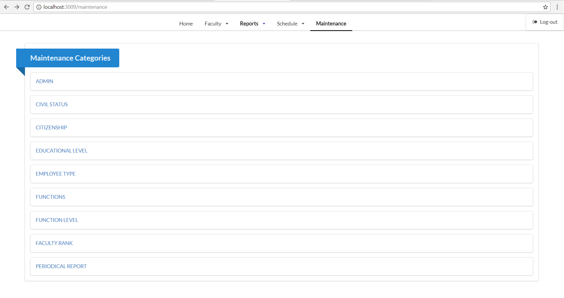

|  |  |
| --- | --- |
| Form Name: | Function Levels |
| Description: | Reveals function level; can be edited or deleted |
| Feature ID: | Feat-002 |

Figure 6.1 Maintenance: Function Level List

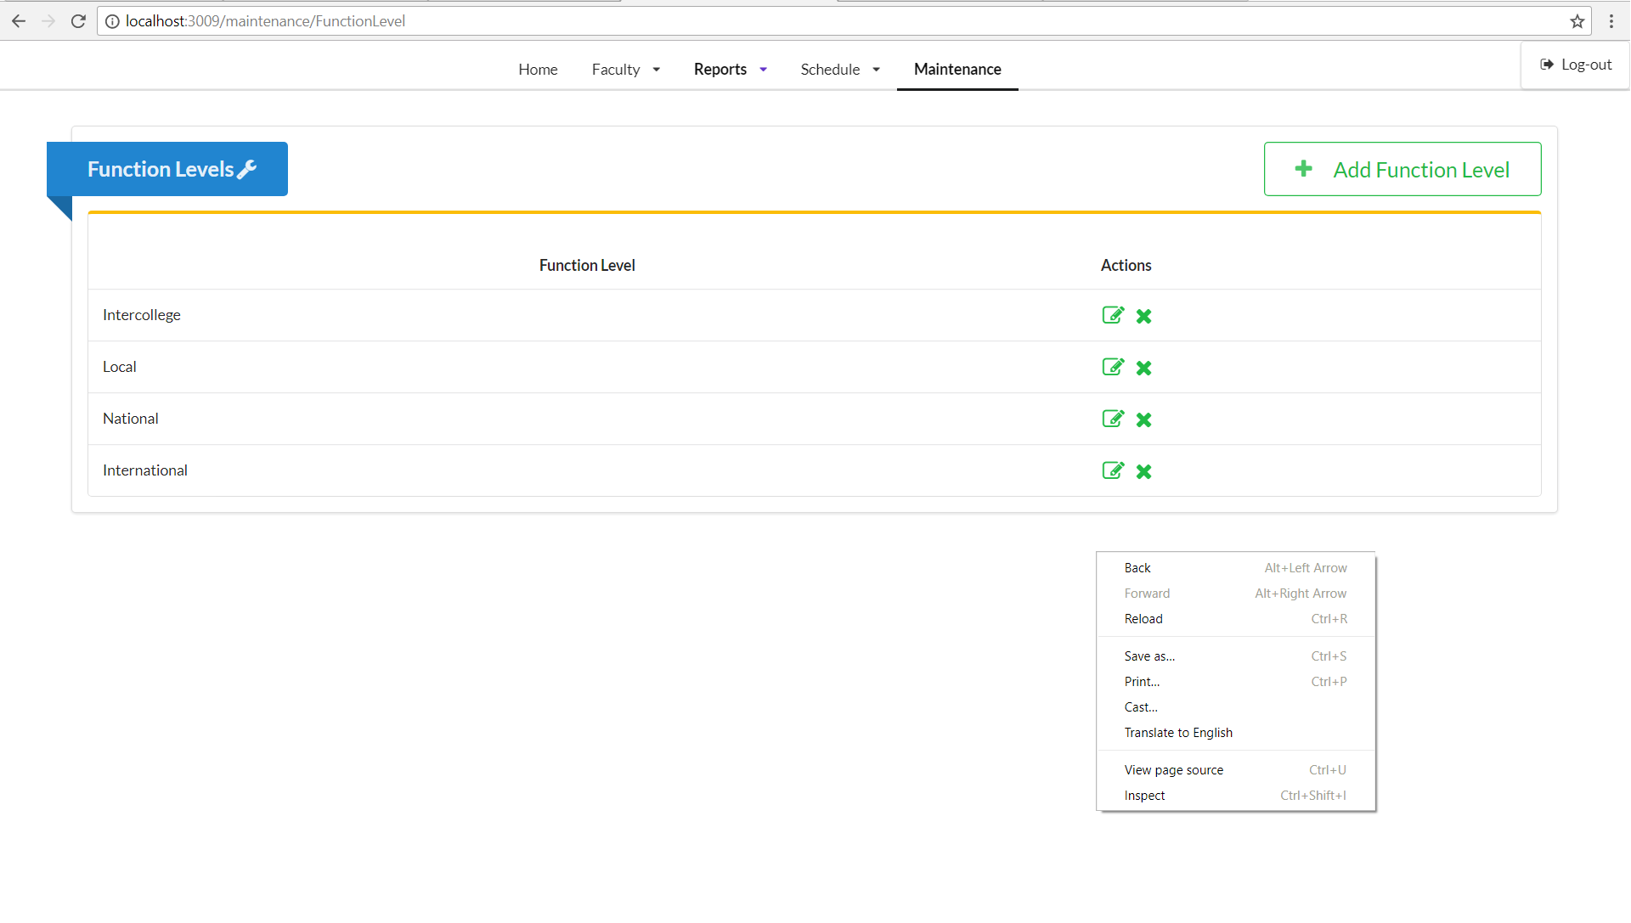

|  |  |
| --- | --- |
| Form Name: | Function Levels – Add |
| Description: | Adds a function level for a professor |
| Feature ID: | Feat-002 |

Figure 6.2 Maintenance: Function Level List - Add

